Do’s and Don’ts in Front Office
Practical No.: 01

Department: Front Office

Time to Train: 2 Hours

1) Establish Eye contact while speaking to guest.

2) Greet everybody you meet and see, with a smile.

3) Address guests and team mates by name at all possible opportunity.

4) When guest ask for direction always guide the way.

5) Never tell a guest that you are tired, working long hours or want go home.

6) Maintain your work area -keep it clean.

7) Pick up any debris.

8) Do a follow up on anything you do for a guest by contacting them personally.

9) Listen to guest complaints / requests carefully if required pen down the details but never contradict or interrupt.

10) Never discriminate against any people, regardless of nationality, race, religion, color, sex or appearance, Give equal treatment for all.

11) Do NOT insult the guest.

12) Do NOT make promises that exceed your authority.

13) Don't Argue with the guest.

14) Always stay calm.

15) Avoid responding with hostility and defensiveness.

16) Don't promise the impossible, instead offer alternate choice.

17) Do report incidents on Log book or to superiors this will help to do any service recovery if needed.

PERSONAL GROOMING & HYGIENE
Practical Number: 2, 3

Department: Front Office

Time to Train: 4 Hours

Guest Expectation:

I expect a high level of personal grooming and hygiene from all employees. I pay high room rates and I expect there to be high standards of grooming and hygiene which complement the facilities of the hotel.

1) Report on Duty:
- Present yourself in a tidy appearance toward our customer and represent highest standards of service.
- Report on duty 5 – 10 minutes before your shift starts.
2) Staff grooming & hygiene:
- Brush your hair before going on duty.
- Ensure that shoes are clean and polished before going on duty.
- Females must wear appropriate stockings with black court shoes where heels do not exceed two inches.
- Males must wear black socks and shoes.
- Change your uniform regularly at Housekeeping Linen Room.
- Clean pressed uniforms must be worn with neatly brushed hair, polished shoes, clean name badge and no buttons missing.
- Contact Housekeeping Uniform Linen Room if buttons are missing.
- Contact HR Department if your name badge is damaged or lost.
- Change your socks/stockings daily.
- Ensure nails are well-trimmed, only clear or pale nail polish for female staff
- Only one ring and watch is permitted, small earrings for female staff.
- Take a bath daily.
- Brush your teeth daily and always wear a smile. Use breath freshener if necessary.
- Teeth should be clean and the breath must be fresh. This can be achieved by cleaning the teeth regularly and visiting the dentist for check-ups on a regular basis.
- Deodorant/eau de toilette cologne/aftershave may be used but not so much that it is offensive.
- Earrings, beards and moustaches are forbidden for male staff.
- Light cosmetics with colors that complement the uniform and skin tones may be worn. Lipstick of a suitable color must be worn at all times.
- If make-up is worn it should be light and natural-looking. Avoid vivid colors, like bright blues or violets around the eyes, and make sure the blusher does not look too dramatic. Bright lipstick colors should also be avoided.
- Be aware of your posture. Walk briskly with a straight back and do not lean on walls.
- Never run in the lobby.
- Check your appearance in a mirror in the locker rooms before going on duty.
- Female hair length beyond the shoulder must be neatly tied/ bundled.
- Men must have short well-combed hair which doesn’t extend below the collar or over the ears.
- Avoid excessive use of hairsprays and gels, as they can make the hair look stiff and unnatural.
- Do not use unnatural hair-colors e.g. green, blue, unnatural blond etc.

Equipments of Front Office Department

Practical Number: 4, 5, 6

Department: Front Office

Time to Train: 6 Hours

LEARNING OBJECTIVE
After studying this topic, one should able to
- Understand about equipment of Front Office
- Identify the various types Equipment’s of Front Office
- Identify the uses and importance of various types of equipment in Front Office

Role of the Front Office Department:-The Front Office Department is the control center of the hotel, providing 24-hours attention towards the handing and serving of all guests’ requirements and needs. Through it flows communications with every other department; from it come instructions and directions for the care and service of the guest; to it comes changes for final billing and settlement.
The Following Photograph shows the Front office department on hotels

Following photograph show the Different Types of hotels Front office view

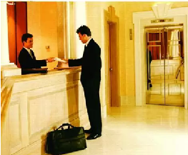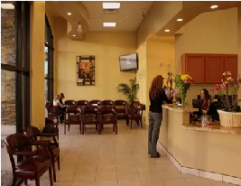
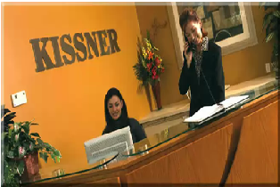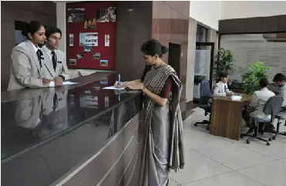

The details of various equipments/ components used in Front Office Operation along with their brief details and functions are as under
Front Office Equipments:-
1) Mail, message and key racks: - This type of equipment used to collect mail, messages and key of the guest. The above picture shows the use of this Rack. The following picture shows the use of this Rack.
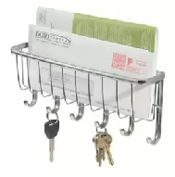
Mail, Message and Key Racks
2) Reservation racks: - This rack is used to collect the Reservation slips of guest which are sent through post or mail.
3) Information racks: - This type of equipment used to collect Information for guest. The Following Photograph is information Rack. The information may be several type like about special menus and visiting location etc.
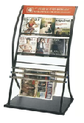
Information Rack
4) Account posting machine: -An accounting machine is generally a calculator and printer combination tailored for a specific commercial activity such as billing, payroll, or ledger.
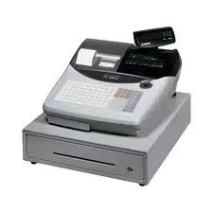
Account Posting Machine
5) Voucher racks: - This Rack is used to keep Vouchers.
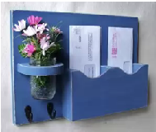
Voucher Rack
6) Cash register: -A cash register is a mechanical or electronic device for calculating and recording sales transactions, and an attached cash drawer for storing cash.
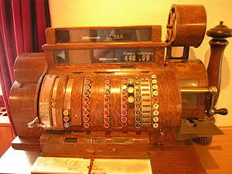
Cash Register Machine
7) Magnetic strip recorder: -a short strip of magnetic tape attached to a credit card or debit card; it contains data that will tell a reading device who you are and what your account number is, etc.
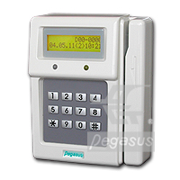
Magnetic Strip Recorder
8) Time Stamp-This machine is used to stamp the time and date on all mails, handwritten messages which come to or are used by the Front Desk. There should be a minimum of 1 per Front Desk
Time Stamp Device
- Adding Machine/Calculator: Minimum of one adding machine for every two Service Associates. Minimum of one printing calculator.
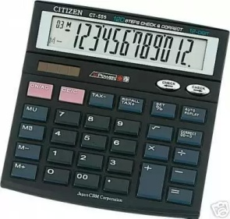
Adding Machine(Calculator)

- Arrival Bucket: This bucket is located adjacent to the registration area and holds the pre-registration envelope for guests due to arrive today. Dividers, similar to folio bucket, are placed inside in alphabetical order.

- Cash Drawer: It is drawer contain several types of column used to place CASH. Two cash drawers per Service Associate’s position.
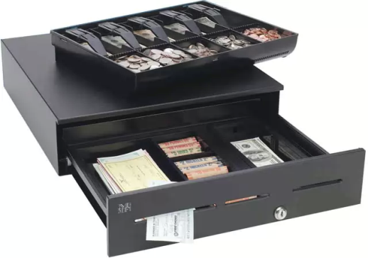
Cash Drawer
- Credit Card: Imprinter One for each Service Associate’s position.
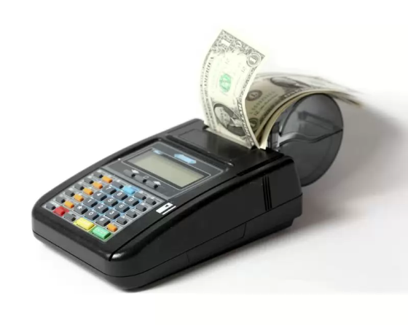
Credit Card Imprinter
- Folio Printers: These are laser printers dedicated to print guest folios and with multi-purpose trays attached to print system generated paid-out and foreign exchange vouchers.
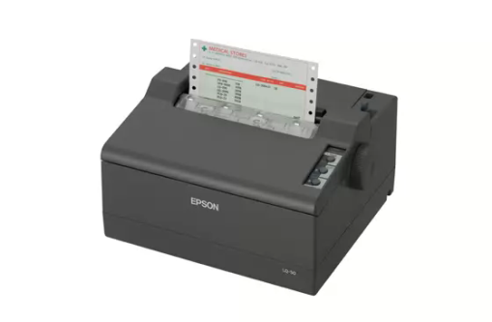
Folio Printer like Laser Printer
- Guest Safety Deposit Box: Safety deposit boxes of varying sizes are located in or adjacent to the front office area. These boxes are for guest use only and are controlled by the Service Associates – Front Desk. Each box has its own key but cannot be opened unless the Service Associate’s guard key is used at the same time. The boxes are controlled through the use of the guest safety deposit box signature card on file.
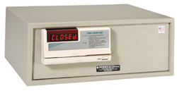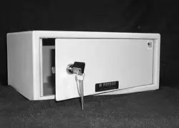
Electronic Guest Safety Box Manually Guest Safety Box
- Key Encoder: Key card issuing machine which should be interfaced with the Fidelio/Opera system (PMS).
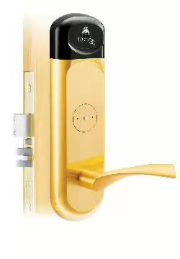Key Encoder
- Postage Scale: This scale is located in the Concierge area and is used to determine the postage required for letters and small packages which a guest or the hotel wishes to mail.
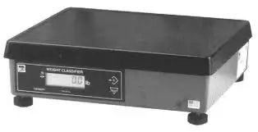Postage Scale
- Registration Card-Buckets: These buckets are used to store in-house guests’ registration cards, supporting documents and credit cards imprints. Each room number to be identified on a thin, plastic divider and placed inside.
Registration Card Bucket

Front Office Interaction with Other Departments in the Hotel
Practical Number: 7, 8
Department: Front Office
Time to Train: 4 Hours
The front ofﬁce staff interacts with all departments of the hotel, including marketing and sales, housekeeping, food and beverage, banquet, controller, maintenance, security, and human resources. These departments view the front ofﬁce as a communication liaison in providing guest services. Each of the departments has a unique communication link with the front ofﬁce staff.
Marketing and Sales Department
The marketing and sales department relies on the front ofﬁce to provide data on guest histories, details concerning each guest’s visit. Some of the information gathered is based on zip code, frequency of visits, corporate affiliation, special needs, and reservations for sleeping rooms. It is also the front ofﬁce’s job to make a good ﬁrst impression on the public, to relay messages, and to meet the requests of guests who are using the hotel for meetings, seminars, and banquets.
The guest history is a valuable resource for marketing and sales, which use the guest registration information to target marketing campaigns, develop promotions, prepare mailing labels, and select appropriate advertising media. The front ofﬁce staff must make every effort to keep this database current and accurate.
The process of completing the booking of a special function (such as a wedding reception, convention, or seminar) depends on the availability of sleeping rooms for guests. The marketing and sales executives may have to check the lists of available rooms three, six, or even twelve months in the future to be sure the hotel can accommodate the expected number of guests. A database of available rooms is maintained in the property management system by the front ofﬁce.
The ﬁrst guest contact with the marketing and sales department is usually through the hotel’s switchboard. A competent switchboard operator who is friendly and knowledge- able about hotel operations and personnel will make a good ﬁrst impression, conveying to the prospective client that this hotel is competent. When the guest ﬁnally arrives for the function, the ﬁrst contact with the hotel is usually through the front ofﬁce staff. The front ofﬁce manager who makes the effort to determine which banquet supervisor is in charge and communicates that information to the desk clerk on duty demonstrates to the public that this hotel is dedicated to providing hospitality.
Messages for the marketing and sales department must be relayed completely, accurately, and quickly. The switchboard operator is a vital link in the communication between the prospective client and a salesperson in the marketing and sales department. The front ofﬁce manager should instruct all new personnel in the front ofﬁce about the staff in the marketing and sales department and what each person’s job entails (this applies to all departments in the hotel, not just marketing and sales). Front ofﬁce employees should know how to pronounce the names of all marketing and sales employees. To help front ofﬁce staff become familiar with all these people, managers should show new employees pictures of the department directors and supervisors. Requests for service at meetings, seminars, banquets, and the like are often made at the front ofﬁce. The banquet manager, a person who is responsible for fulfilling the details of service for a banquet or special event, or sales associate, a person who books the guest’s requirements for banquets and other special events, might be busy with another function. If a guest needs an extension cord or an electrical outlet malfunctions, the front desk staff must be ready to meet the guest’s needs. The front ofﬁce manager should establish standard operating procedures for the front ofﬁce employees to contact maintenance, house- keeping, marketing and sales, or the food and beverage department to meet other common requests. Knowing how to ﬁnd a small tool kit, adapters, adhesive materials, extra table covers, or window cleaner will help the guest and will save the time involved in tracking down the salesperson in charge.
Housekeeping Department
Housekeeping and the front ofﬁce communicate with each other about housekeeping room status, the report on the availability of the rooms for immediate guest occupancy. Housekeeping room status can be described in the following communication terms:
• Available Clean, or Ready—room is ready to be occupied • Occupied—guest or guests are already occupying a room • Stayover—guest will not be checking out of a room on the current day • Dirty or On-Change—guest has checked out of the room, but the housekeeping staff has not released the room for occupancy • Out-of-Order—room is not available for occupancy because of a mechanical malfunction
Housekeeping and the front ofﬁce also communicate on the details of potential house count (a report of the number of guests registered in the hotel), security concerns, and requests for amenities (personal toiletry items such as shampoo, toothpaste, mouthwash, and electrical equipment). These issues are of immediate concern to the guest as well as to supervisors in the hotel.
Reporting of room status is handled on a face-to-face basis in a hotel that does not use a property management system (PMS). The bihourly or hourly visits of the house- keeper to the front desk clerk are a familiar scene in such a hotel. The ofﬁcial reporting of room status at the end of the day is accomplished with a housekeeper’s room report—a report prepared by the housekeeper that lists the guest room occupancy status as vacant, occupied, or out-of-order. Sometimes even regular reporting of room status is not adequate, as guests may be anxiously awaiting the opportunity to occupy a room. On these occasions, the front desk clerk will have to telephone the ﬂoor supervisor to determine when the servicing of a room will be completed.
The housekeeper relies on the room sales projections—a weekly report prepared and distributed by the front ofﬁce manager that indicates the number of departures, arrivals, walk-ins, stayovers, and no-shows—to schedule employees. Timely distribution of the room sales projections assists the executive housekeeper in planning employee personal leaves and vacation days.
The front desk also relies on housekeeping personnel to report any unusual circumstances that may indicate a violation of security for the guests. For example, if a maid or houseman notices obviously non-registered guests on a ﬂoor, a ﬁre exit that has been propped open, or sounds of a domestic disturbance in a guest room, he or she must report these potential security violations to the front ofﬁce. The front ofﬁce staff, in turn, will relay the problem to the proper in-house or civil authority. The front ofﬁce manager may want to direct the front desk clerks and switchboard operators to call ﬂoor supervisors on a regular basis to check activity on the guest ﬂoors.
Guest requests for additional or special amenities and guest room supplies may be initiated at the front desk. The prompt relay of requests for extra blankets, towels, soap, and shampoo to housekeeping is essential. This is hospitality at its best.
Food and Beverage Department
Communication between the food and beverage department and the front ofﬁce is also essential. Some of this communication is conveyed by relaying messages and providing accurate information on transfers, which are forms used to communicate a charge to a guest’s account. Communication activities also include reporting predicted house counts, an estimate of the number of guests expected to register based on previous occupancy activities, and processing requests for paid-outs, forms used to indicate the amounts of monies paid out of the cashier’s drawer on behalf of a guest or an employee of the hotel. These vital services help an overworked food and beverage manager, restaurant manager, or banquet captain meet the demands of the public.
Incoming messages for the food and beverage manager and executive chef from vendors and other industry representatives are important to the business operation of the food and beverage department. If the switchboard operator is given instructions on screening callers (such as times when the executive chef cannot be disturbed because of a busy workload or staff meetings, or vendors in whom the chef is not interested), the important messages will receive top priority.
In a hotel that has point-of-sale terminals, computerized cash registers that interface with a property management system, information on guest charges is automatically posted to a guest’s folio, his or her record of charges and payments. When a hotel does not have point-of-sale terminals that interface with PMS point-of-sale terminals, the desk clerk is responsible for posting accurate charges on the guest folio and relies on transfer slips. Also, the night auditor’s job is made easier if the transfer slip is accurately prepared and posted. The front ofﬁce manager should work with the food and beverage director in developing standard operating procedures and methods to complete the transfer of charges.
The supervisors in the food and beverage department rely on the predicted house count prepared by the front ofﬁce manager to schedule employees and predict sales. For ex- ample, the restaurant supervisor working the breakfast shift will want to know how many guests will be in the hotel so he or she can determine how many servers to schedule for breakfast service. Timely and accurate preparation of this communication tool assists in staffing control and sales predictions.
Authorized members of the food and beverage department will occasionally ask the front ofﬁce for cash, in the form of a paid-out, to purchase last-minute items for a banquet, the lounge, or the restaurant or to take advantage of other unplanned opportunities to promote hospitality. Specific guidelines concerning cash limits, turnaround time, prior approval, authorized signatures, and purchase receipts are developed by the general manager and front ofﬁce manager. These guidelines help to maintain control of paid-outs.
Banquet Department
The banquet department, which often combines the functions of marketing and sales department and a food and beverage department, requires the front ofﬁce to relay information to guests about scheduled events and bill payment.
The front desk staff may also provide labor to prepare the daily announcement board, an inside listing of the daily activities of the hotel (time, group, and room assignment), and marquee, the curbside message board, which includes the logo of the hotel and space for a message. Since the majority of banquet guests may not be registered guests in the hotel, the front ofﬁce provides a logical communications center.
The daily posting of scheduled events on a felt board or an electronic bulletin board provides all guests and employees with information on group events. The preparation of the marquee may include congratulatory, welcome, sales promotion, or other important messages. In some hotels, an employee in the front ofﬁce contacts the marketing and sales department for the message.
The banquet guest who is unfamiliar with the hotel property will ask at the front ofﬁce for directions. This service might seem minor in the overall delivery of service, but it is essential to the lost or confused guest. The front ofﬁce staff must know both how to direct guests to particular meeting rooms or reception areas and which functions are being held in which rooms. Front desk clerks, as shown in Figure 3-2, must be ready to provide information for all departmental activities in the hotel.
The people responsible for paying the bills for a special event will also ﬁnd his or her way to the front ofﬁce to settle the city ledger accounts. If the banquet captain is not able to present the bill for the function, the front desk clerk should be informed about the specifics of food and beverage charges, gratuities, rental charges, method of payment, and the like.
Controller
The controller relies on the front office staff to provide a daily summary of financial transactions through a well-prepared night audit. This information is also used to measure management ability to meet budget targets. Since the front office provides the controller with financial data for billing and maintenance of credit-card ledgers, these two departments must relay payments and charges through the posting machine or property management system.
Maintenance or Engineering Department
The maintenance or engineering department and front office communicate on room status and requests for maintenance service. Maintenance employees must know the occupancy status of a room before attending to plumbing, heating, or air-conditioning problems. If the room is reserved, the two departments will work out a time frame so the guest will be able to enter the room or be assigned to another room. Cooperative efforts produce the best solutions to sometimes seemingly impossible situations.
Likewise, the requests from guests for the repair of heating, ventilating, and air- conditioning units; plumbing; televisions; and other room furnishings are directed to the front desk. These requests are then communicated to the maintenance department. The front desk clerk must keep track of the repair schedule, as guests want to be informed of when the repair will be made.
Security Department
Communications between the security department and the front office are very important in providing hospitality to the guest. These departments work together very closely in maintaining guest security. Fire safety measures and emergency communication systems as well as procedures for routine investigation of guest security concerns require the cooperation of these departments.
Human Resources Management Department
The human resources management department may rely on the front office staff to act as an initial point of contact for potential employees in all departments. It may even ask the front office to screen job candidates. If so, guidelines for and training in screening methods must be provided.
Some directors of human resources management depend on the front office to distribute application forms and other personnel-related information to job applicants. The potential employee may ask for directions to the personnel office at the front desk. The human resources management department may also develop guidelines for the front desk clerk to use in initially screening candidates. For example, the guidelines may include concerns about personal hygiene, completion of an application, education requirements, experience, and citizenship status. This information will help the executives in the human resources management department interview potential job candidates.

Handling situations & guest complaints
Practical Number: 9, 10
Department: Front Office
Time to Train: 4 Hours
Front office management and staff should keep the following resolution guidelines in mind when handling guest complaints.
When expressing a complaint, the guest may be quite angry. Front office staff members should not make promises that exceed their authority. If a problem cannot be solved, front office staff should admit this to the guest early on.
Honesty is the best policy when dealing with guest complaints. Front office staff should be advised that some guests complain as part of their nature. The staff should develop an approach for dealing with such guests.
Top Ten ways of handling guest Complaints:
- Listen with concern and empathy.
- Isolate the guest if possible, so that other guests won't overhear.
- Stay calm. Don't argue with the guest.
- Be aware of the guest's self-esteem. Show a personal interest in the problem, Try to use the guest name frequently.
- Give the guest your undivided attention. Concentrate on the problem, no on placing blame. Do NOT Insult the guest.
- Take notes. Writing down the key facts saves time if someone else must get involved. Also, Guest tends to slow down when they see the front desk agent trying to write down the issue.
- Tell the guest what can be the best done. Offer choices. Don't promise the impossible, and don't exceed your authority.
- Set an approximate time for completion of corrective actions. Be specific, but do not underestimate the amount of time it will take to resolve the problem.
- Monitor the progress of the corrective action.
- Follow up. Even if the complaint was resolved by someone else, Contact the guest to ensure that the problem was resolved satisfactory.

Key terms used in hotel Front office department
Practical Number: 11
Department: Front Office
Time to Train: 2 Hours

American plan (AP) - A billing arrangement under which room charges include the guestroom and three meals, also called as full board / full pension.
European plan (EP) - A billing arrangement under which meals are priced separately or room only plan
Modified American Plan (MAP) - A billing arrangement under which the daily rate is including room and two meals, generally Breakfast and dinner.
Continental Plan (CP) - One of the most common / preferred billing arrangement which includes room and continental breakfast.
Rack Rate - The published tariff for each room type / category in a hotel.
Log Book - Located at reception containing instructions/information/ happenings / handover of the day to know of.
Registration Card- A printed form for a registration record, In most countries the guest's signature on a registration card is required by law.
Reservation Status - An indicator of a room's long term availability for assignment.
Room Rate - The price a hotel charges for overnight accommodations.
Skipper - A guest who leaves with no intention of paying for the room.
Scanty Baggage - A guest who checks in to the hotel with very less or no luggage.
Walk -in - A guest who arrives at a hotel without a reservation.
Walking - Turning away a guest who has a reservation because of a lack of room availability.
Due outs - Guests expected to check out on a given day who have not yet done so.
Credit limit / house limit - A limit assigned by the hotel to guest or company accounts.
Up selling - A sales technique whereby a guest is offered a more expensive room than what he or she reserved or originally requested, and then persuaded to rent the room based on the room's features, benefits, and his or her needs.
Block - An agreed-upon number of rooms set aside for members of a group planning to stay in a hotel.
Book - To sell or reserve rooms ahead of time.
Confirmation Number - A code that provides a unique reference to a reservation record and assures the guest that the reservation record exists.
Confirmed Booking - When Reservation is guaranteed with Credit card, Deposit, Company / TA voucher etc.
Tentative Booking - When reservation is waiting bookers confirmation.
Waitlisted Booking - Reservation kept on hold due to hotel over
Cut-off date - The date agreed upon between a group and a hotel after which all unreserved rooms in the group's block will be released back to the general availability.
Cancelation date - Indicates the date when the reservation was manually canceled.
No-Show - A guest who made a room reservation but did not register or Check in.
Long Stay - A Guest who stays more than certain number of days, Eg: More than 7 days etc.
Overbooking - accepting more reservations than there are available rooms.
Wash down - Blocking fewer rooms than the number requested by a group, based on previous group history.
Guest Cycle - A division of the flow of business through a hotel that identifies the physical contacts and financial exchanges between the guests and the hotel.
Guest Folio - A form ( paper or electronic ) used to chart transactions on a account assigned to an individual person or guest room.
Late Charge - A transaction requiring posting to a guest account that does not reach the front office for posting before the guest had checked out or done the final settlement.
Global Distribution System (GDS) - A distribution channel for reservations that provides worldwide distribution of hotel reservation information and allows selling of hotel reservations around the world, usually accomplished by connecting the hotel reservation system with an airline reservation system ( Eg - Amadeus, Saber, Galileo/Apollo or Worldspan )
PMS - Property Management System
TA - Travel Agent who receives commission for the bookings.
OTA - Online Travel Agents
Void - Reversal of Charges which was posted on the same day
Allowance - Reversal of charges which was posted before current system / PMS date.TY:
Amenity- Service or item offered to guests or placed in guest rooms for the comfort and convenience of guests, and at no extra cost. Examples are various guest services (such as in-room entertainment systems, automatic check-out, free parking, concierge services, and multilingual staff) in addition to an array of personal bathroom items offered by most hotels and motels. Amenities are designed to increase a hotel's appeal, enhance a guest's stay, and encourage guests to return.
AVERAGE OCCUPANCY:
Average occupancy- A ratio that shows rooms sold over a fixed period of time as a percentage of total available rooms in a property over the same period of time.
AVERAGE OCCUPANCY PER ROOM:
Average occupancy per room- A ratio that shows the average number of paid guests for each room sold. Calculated by dividing number of paid room guests by number of rooms sold.
AVERAGE ROOM RATE:
Average room rate- A ratio that indicates average room rate, and to what extent rooms are being up-sold or discounted; calculated by dividing rooms revenue by number of rooms sold. Also called average daily rate or ADR.

Back of the house- The functional areas of a hotel or restaurant in which employees have little or no direct guest contact, such as kitchen areas, engineering and maintenance, and the accounting department.
BED & BREAKFAST (B&B):
Bread & breakfast- A small inn or lodge that provides a room and a breakfast. Often a B&B is in a residential home setting and/or a historic building converted to a quaint lodging facility.
CABANA:
Cabana- A guest room adjacent to the pool area, with or without sleeping facilities
CARD KEY:
Card key- A plastic card, resembling a credit card, used in place of a metal key to open a guest room door. Card keys require electronic locks.
CASINO HOTEL:
Casino hotel- A hotel that features legal gambling, with the hotel operation subordinate to the gambling operation.
CHECK-IN:
Check-in- The procedures for a guest's arrival and registration.

Check-out- The procedures for a guest's departure and the settling of his or her account.(2) A room status term indicating that the guest has settled his or her account, returned the room keys, and left the property.
COMPLIMENTARY ROOM:
Complimentary room- A complimentary or "comp" room is an occupied room for which the guest is not charged. A hotel may offer comp rooms to a group in ratio to the total number of rooms the group occupies. One comp room may be offered for each fifty rooms occupied, for example.
Account payable – Financial obligations the hotel owes to private and government-related agencies and vendors.
Account receivable – Amount of money owed to the hotel by guests.
Assets – Items that have monetary value.
Atrium concept – A design in which guest rooms overlook the lobby from the first floor to the roof.
Average Daily Rate ( ADR ) – A measure of the hotel staff’s ability to sell available room rates; the method to compute the ADR is :
Room revenue / number of rooms sold
Balance sheet – An official financial listing of assets, liabilities and owner’s equity.
Bank card – credit cards issued by banks, examples of which include Visa, MasterCard, JCB.
Banquet sheet – a listing of the details of an event at which food and beverage are served.
Bill-to-account – An extension of credit to a guest by an individual hotel that requires the guest or the guest’s employer to establish a line of credit and to adhere to a regular payment schedule.
Biometrics – An individual electronic measurement of uniqueness of human being such as voice, hand print or facial characteristics.
Blackout – Total loss of electricity.
Blocking on the horizon – Reserving guest rooms in the distant future.
Blocking procedure – Process of reserving a room on a specific day.
Bottom up – A sales method that involves presenting the lest expensive rate first.
Brownouts – Partial loss of electricity.
Business affiliation – Chain or independent ownership of hotels.
Call accounting – A computerized system that allows for automatic tracking and posting of outgoing guest room calls.
Cancellation code – A sequential series of alphanumeric combinations that provide the guest with a reference for a cancellation of a guaranteed reservation.
Cash bank – A specific amount of paper money and coins issued to a cashier to be used for making change.
Cashier – A person who processes guest check outs and legal tender and make change for guest.
Cashier’s report – A daily cash control report that list cashier activity of cash and credit cards and machine totals by cashier shift.
Chain – A group of hotels that follow standard operating procedures such as marketing, reservations, quality of service, food and beverage operations, housekeeping and accounting.
City ledger account – A collection of accounts receivable of nonregistered guest who use the service of the hotel.
Commercial cards – Credit cards issued by cooperation, an example of which is Diners Club.
Concierge – A person who provides an endless array of information on entertainment, sports, amusement, transportation, tours, church services and babysitting in a particular city or town.
Conference call – A conversation in which three or more persons are linked by telephone.
Confirmed reservations – Prospective guests who have a reservation for accommodations that is honored until a specified time.
Corporate client – A hotel guest who represents a business or is a guest of that business and provides the hotel with an opportunity to establish a regular flow of business during sales periods that would normally be flat.
Corporate guests– frequent guests who are employed by a company and receive a special room rate.
Corporate rates – Room rate offered to corporate clients staying in the hotel.
Credit – A decrease in an asset or an increase in liability, or an amount of money the hotel owes the guest.
Credit balance – Amounts of money a hotel owes guests in future services.
Credit card imprinter – makes an imprint of the credit card the guest will use as the method of payment.
Current guests – Guest who are registered in the hotel
Daily sales report – A financial activity report produced by a department in a hotel that reflects daily sales activities with accompanying cash register tapes or point-of-sales audit tapes.
Debit cards – Embossed plastic cards with a magnetic strip on the reverse side that authorize direct transfer of fund from a customer’s bank account to the commercial organization’s bank account for purchase of goods and services.
Double Occupancy Percentage – A measure of a hotel’s staff ability to attract more than one guest to a room; the method to compute double occupancy percentage is:
Number of guest – number of rooms sold / number of rooms sold X 100%
Eco tourists – Tourist who plan vacation to understand the culture and environment of a particular area
Electronic key – A plastic key with electronic codes embedded on a magnetic strip.
Electronic key system – A system composed of battery-powered or, less frequently, hardwired locks; a host computer and terminals; a keypuncher; and special entry cards that are used as keys.
Express check out – Means by which the guest uses computer technology in a guest room or a computer in the hotel lobby to check out.
Family rate – room rates offered to encourage visit by families with children.
Float – The delay in payment from an account after using a credit card or personal check.
Floor limit – A dollar amount set by the credit card agency that allows for a maximum amount of guest charges.
Folio – A guest’s record of charges and payment.
Full house – 100 percent hotel occupancy; a hotel that has all its guest room occupied.
Global Distribution System (GDS) – Distributor of hotel rooms to corporations such as travel agents that buy rooms in large volume.
Boutique Hotel- Historical, classic buildings, remodeled into boutique hotels with usually have less than 30 rooms.

